ENVIRONMENTAL CONSERVATION
IN INDIA
Environmental conservation is the practice of protection, preservation and sustainable management of natural resources such as forests, water, air and biodiversity. In India, rapid urbanization, industrial growth, and population pressure have increased environmental challenges, making conservation efforts critical for long term sustainability.
Human life cannot thrive without a balanced and healthy ecosystem. The environment includes all living and non-living elements and the way they interact within a natural setting. Today, environmental conservation has become a crucial global concern, especially as we face the serious challenges of climate change and global warming.
With rapid industrialisation harming natural resources, sustainable development is now essential to protect the planet and secure our future.

KEY FINDINGS AND AI INSIGHTS
- There is usually a major uprise in the AQI Index during the Winter season. This is due to the following reasons:
- Temperature Inversion
- Stubble Burning
- Low Wind Speed
- Increased Emissions
- Almost 3/4th (74.64%) of the land in India is Non-Forested Land. According to India’s National Forest Policy, the forest cover target is 33%. However, we are currently at 25.17%, being 8% short of the target.
- With Urban population growing at over 2% annually, Indian cities are warming at nearly twice the rate of the rest of the country. An average increase of 0.53% per decade, with 0.2% directly attributed to urbanization.
- India’s energy-related Carbon Dioxide emissions rose by 5.3% in 2024: the highest rate among major economies, driven by infrastructure development and surging energy demand.

IMPORTANT STATISTICS AND TRENDS

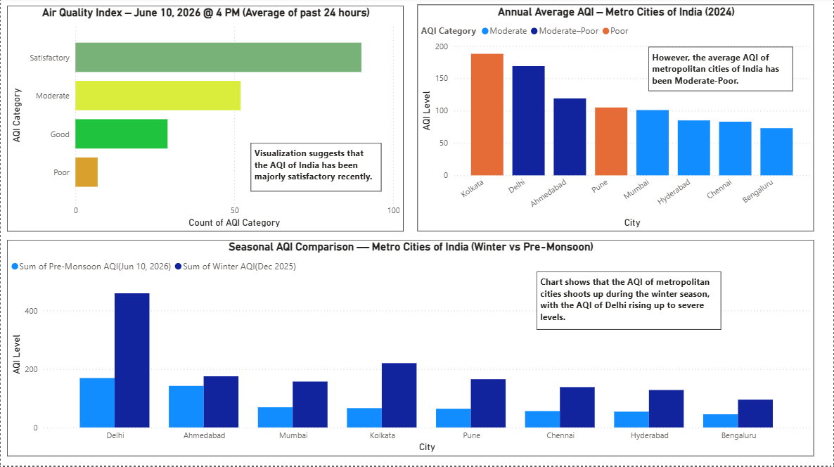

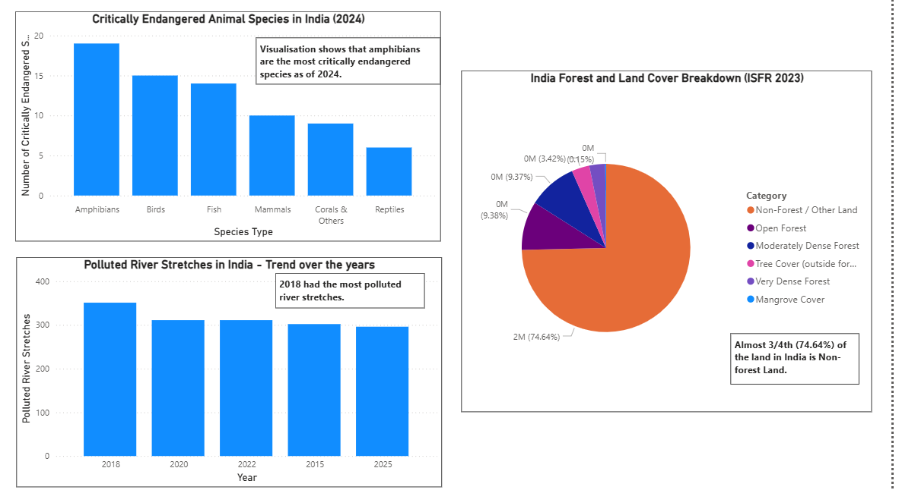

CHALENGES IDENTIFIED
- The AQI of metropolitan cities remains to be very high, especially during winters, with the AQI of Delhi being as high as 459.
- The number of polluted river stretches, although decreased, still remains to be very high as of 2025, at 296.
- India is 8% behind its forest cover target of 33%.

RECOMMENDATIONS OR SOLUTIONS
- Waste Management: Especially in developing countries and congested places, on a daily basis, a large amount of waste is thrown away recklessly on the streets and roads. The improper disposal of waste segregation can lead to various dreadful diseases as well as soil pollution.
- Public Awareness: With the boom of information technology and the advent of digital media, public awareness about environmental conservation can potentially yield promising results. It is crucial to raise public awareness about the harmful effects of environmental pollution and degradation.
- Pollution Control: As the increase in temperature is concerning, there is a need to keep a watch on the toxic compounds we ingest that pollute the atmosphere. We need to adopt environmentally sustainable methods to minimise multiple forms of emissions.
- Forest Conservation: Afforestation is amongst the core Environmental conservation and aims to plant more trees as well as save the existing ones from being cut down, as trees play a crucial role in maintaining the ecological balance.

CONCLUSION
Various core environmental issues are taking a heavy toll on human lives. Ranging from overpopulation, hydrological issues, ozone depletion, and global warming to deforestation, desertification and pollution, all these issues pose a severe threat to the existence of humankind. Unless environmental conservation becomes an effective mass movement, it is futile to expect positive growth, especially in the age of digital media, which holds the potential to bring a revolution to save our planet from destruction.

SOURCES
- MoEFCC 2022 | IUCN Red List 2023-1 update
- CPCB Polluted River Stretches Reports (2015–2025)
- Forest Survey of India, ISFR 2023
- CPCB website
- Charts and Visualizations were prepared by me on Power BI

-Report by:
Kripa Popli

